# Amazon CloudWatch

## Steps

### Create EC2 Instance - Follow the steps for EC2

Linux box is fine

### Create SNS Topic. Subscribe to your email address.

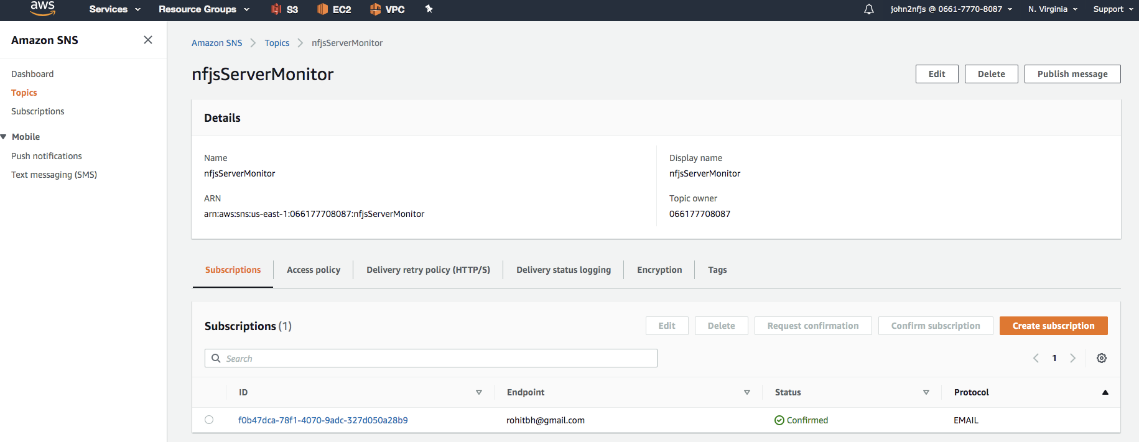

### Create CloudWatch Event Rule

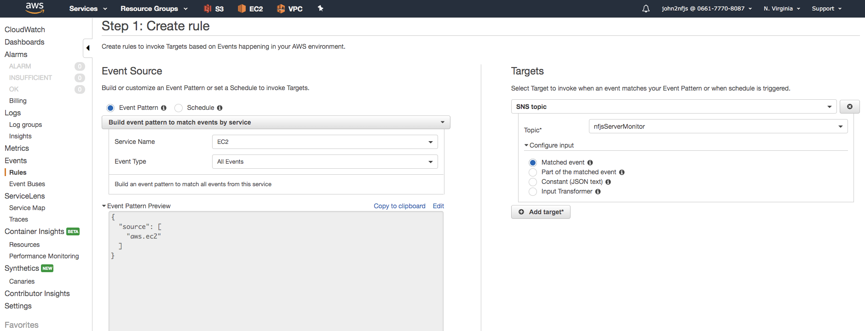

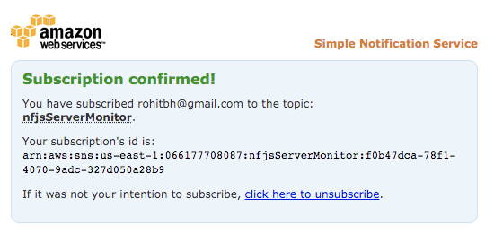

EC2

Select Target SNS topic we created earlier

### Stop and start the EC2 server to simulate an SNS Notification Email from the CloudWatch Event.

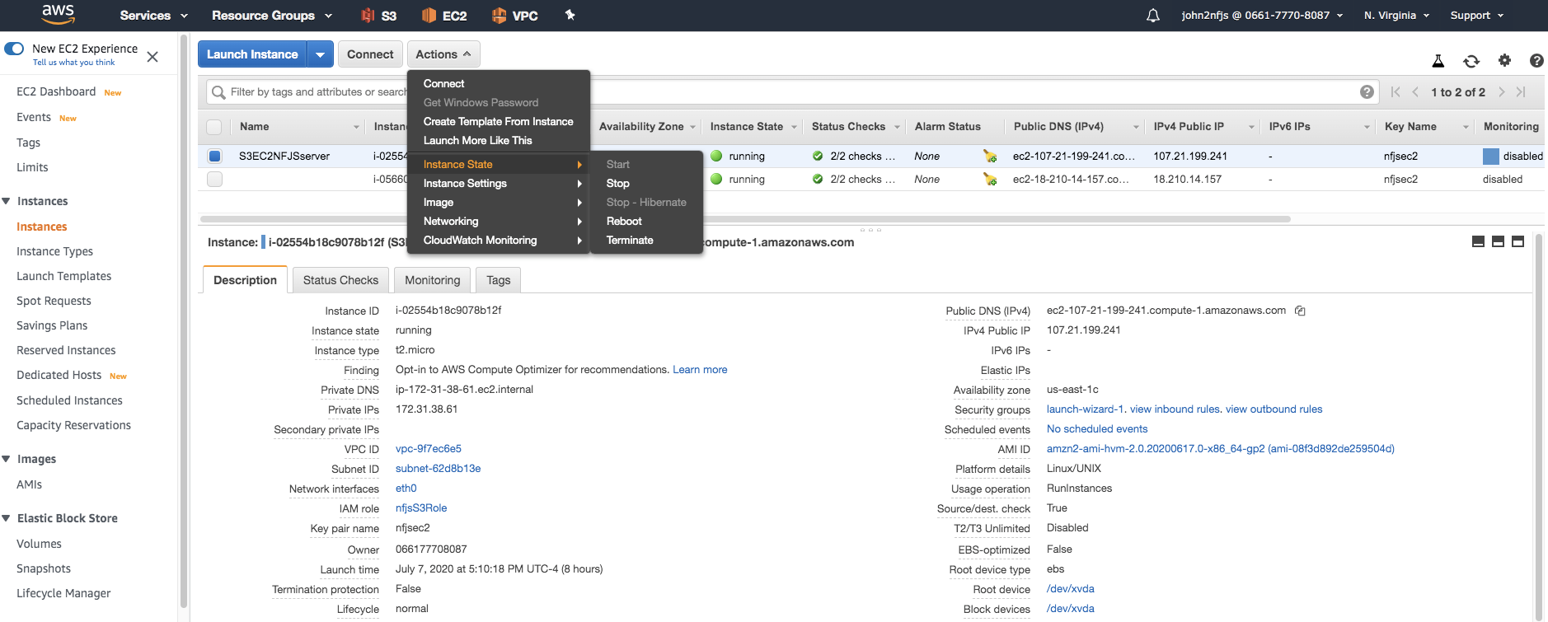

Stop and start the EC2 instance

### SNS email received

|  |  |  |  |  |
| --- | --- | --- | --- | --- |
| |  | | --- | | **nfjsServerMonitor <no-reply@sns.amazonaws.com>** | | 1:27 AM (0 minutes ago) |  |  |
| |  | | --- | | to me | | | |

{"version":"0","id":"6cafce53-0547-ad5e-69e9-87c8063cdd1f","detail-type":"EC2 Instance State-change Notification","source":"aws.ec2","account":"066177708087","time":"2020-07-08T05:27:25Z","region":"us-east-1","resources":["arn:aws:ec2:us-east-1:066177708087:instance/i-02554b18c9078b12f"],"detail":{"instance-id":"i-02554b18c9078b12f","state":"stopped"}}